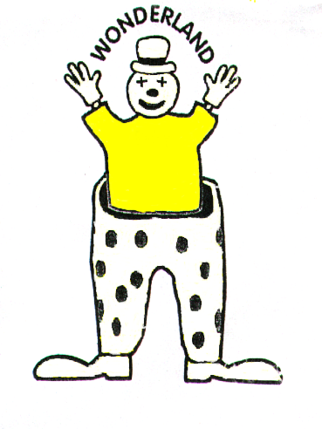

Wonderland Day Nursery and Pre-School

The Old School,

Gundry lane,

Bridport

Dorset

DT6 3RL

Telephone: 01308 421731

Registered with Ofsted Reg no 139373

Email: wonderlandnursery@tiscali.co.uk

Modern Slavery and Human Trafficking Policy
Legislation
The Modern Slavery Act, received Royal Assent on 26 March 2015. The act consolidates slavery and trafficking offenses and introduces tougher penalties and sentencing rules.
Background
Child trafficking and modern slavery is becoming a more frequent form of child abuse. Children are recruited, moved, transported and then exploited, forced to work or are sold on.
Modern slavery is a term that covers:
- Slavery
- Servitude and forced or compulsory labour
- Human trafficking.

Victims of modern slavery are also likely to be subjected to other types of abuse such as physical, sexual and emotional abuse. This policy should be used alongside the following policies to ensure all children, staff, parents and visitors are fully safeguarded:
- Safeguarding and child protection
- Whistleblowing
- Equality and inclusion

For an adult or child to have been a victim of human trafficking there must have been:
- Action (e.g. recruitment, transportation, transfer, harbouring or receipt of a child for the purpose of exploitation)
- Means (threat or use of force, coercion, abduction, abuse of power or vulnerability) There does not need to be “means” for children as they are not able to give informed consent
- Purpose (e.g. sexual exploitation, forced labour or domestic servitude, slavery, financial exploitation, illegal adoption, removal of organs).

Procedure:
When a concern is raised about slavery or trafficking then we will follow our safeguarding procedure. If the child (or adult) is at risk of immediate harm then the police will be called, otherwise the local authority will be contacted and the referral process will be followed as per the safeguarding procedure

Written January 2019

